PROGRAME SOURCE CODE:
module comperater(Grt,Les,Equ,A,B);
input [3:0]A,B;
output Grt,Les,Equ;
assign Grt=(A>B);
assign Les=(A<B);
assign Equ=(A==B);
endmodule
TEST BENCH:
module tb_comperater();
reg [3:0]A,B;
wire Grt,Les,Equ;
comperater j4 (Grt,Les,Equ,A,B);
initial
begin A=4'b1001; B=4'b0110;
end
initial #100 $stop;
initial $monitor($time,"Grt=%b,Les=%b,Equ=%b,A=%b,B=%b",Grt,Les,Equ,A,B);
endmodule
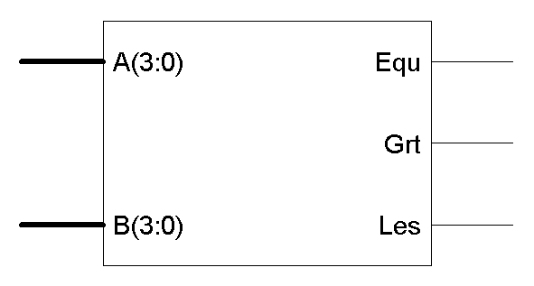

PROGRAME SOURCE CODE:
module lfsr(y,clk,reset);
parameter l=8; //l=length
parameter is=8'b10010001; //is=Initial state
parameter [1:l]tc=8'b1111_0011; //tc=top coefficient
output [1:l]y;
input clk,reset;
reg [1:l]y;
always@(posedge clk)
if(reset==1'b0)
y<=is;
else
begin
y[1]<=y[8];
y[2]<=tc[7] ? y[1]^y[8]:y[1];
y[3]<=tc[6] ? y[2]^y[8]:y[2];
y[4]<=tc[5] ? y[3]^y[8]:y[3];
y[5]<=tc[4] ? y[4]^y[8]:y[4];
y[6]<=tc[3] ? y[5]^y[8]:y[5];
y[7]<=tc[2] ? y[6]^y[8]:y[6];
y[8]<=tc[1] ? y[7]^y[8]:y[7];
end
endmodule
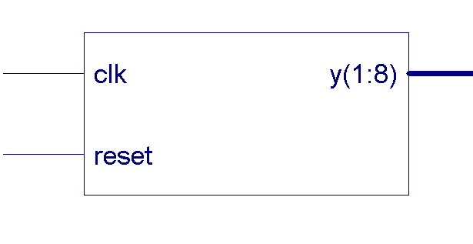
PROGRAME SOURCE CODE:
module rca_4bit(s0,s1,s2,s3,cout,cin,a0,a1,a2,a3,b0,b1,b2,b3);
output s0,s1,s2,s3;
output cout;
input cin;
input a0,a1,a2,a3;
input b0,b1,b2,b3;
wire c0,c1,c2,c3;
fu_add x1(s0,c1,a0,b0,cin);
fu_add x2(s1,c2,a1,b1,c1);
fu_add x3(s2,c3,a2,b2,c2);
fu_add x4(s3,cout,a3,b3,c3);
endmodule
//------- Program for Full adder-----------
module fu_add(s,co,a,b,ci);
input a,b,ci; output s,co;
wire c1,c2,s1; ha_add x1(s1,c1,a,b);
ha_add x2(s,c2,s1,ci); or(co,c1,c2);
endmodule
//---------Program For Half Adder--------
module ha_add(s,c,a,b);
output s,c; input a,b;
xor(s,a,b); and(c,a,b);
endmodule
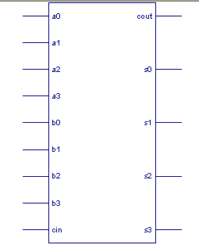

PROGRAME SOURCE CODE:
//---------Mealy FSM------------
module mealy_st0(a,clk,reset,z);
input a,clk,reset;
output z;
reg z;
parameter st0=4'b00, st1=4'b01, st2=4'b10;
reg[0:1]p_state, n_state;
// sequential logic
always@(posedge reset or posedge clk)
if(reset) p_state<=st0;
else p_state<=n_state;
// combinational logic
always@(p_state or a)
case(p_state)
st0: begin
z=(a)?1:0; n_state=(a)?st2:st0;
end

PROGRAME SOURCE CODE:
module universal_shift(s0,s1,pin,left,rite,a,clk,clr);
input s0,s1,left,rite,clk,clr;
input [3:0]pin; output [3:0]a;
reg [3:0]a; always @(posedge clk or posedge clr)
if(clr) a=4'b0; else
begin case ({s0,s1})
2'b00:a=a;
2'b01:a={rite,a[3:1]}; 2'b10:a={a[2:0],left};
2'b11:a=pin; endcase
End endmodule
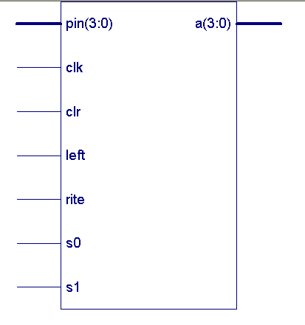

PROGRAME SOURCE CODE:
module pipeline_adder(rega,regb,regc,d,clk,reset);
output [1:0]rega,regb,regc;
input [1:0]d; input clk,reset;
reg [1:0]rega,regb,regc;
always@(posedge clk or posedge reset)
if(reset)
begin
rega=2'b00; regb<=2'b00; regc<=2'b00;
end else
begin
rega=d; regb<=rega+1; regc<=regb+1;
end endmodule
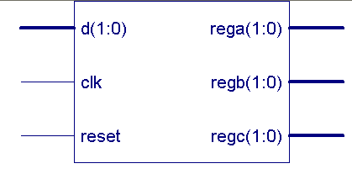

PROGRAME SOURCE CODE:
module ring_counter(en,reset,clk,count);
input en,reset,clk; output [3:0]count;
reg [3:0]count;
always @(posedge reset or posedge clk)
if(reset)
count=4'b0001;
else if(en)
count={count[2:0],count[3]};
endmodule
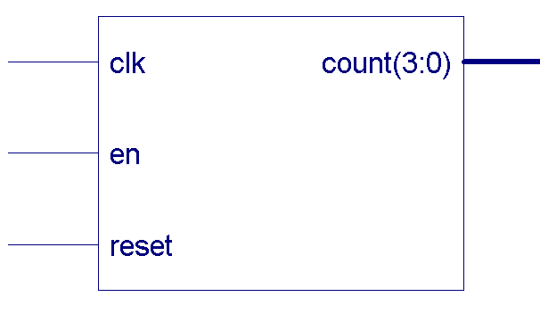

PROGRAME SOURCE CODE:
module mull_4bit(s,a,b);
output [7:0] s; input [3:0] a,b; wire [23:0] w;
and g1(s[0],a[0],b[0]);
and g2(w[0],a[0],b[1]);and g3(w[1],a[0],b[2]);and g4(w[2],a[0],b[3]);
and g5(w[4],a[1],b[0]); and g6(w[5],a[1],b[1]); and g7(w[6],a[1],b[2]);and g8(w[7],a[1],b[3]);
and g9(w[12],a[2],b[0]);and g10(w[13],a[2],b[1]); and g11(w[14],a[2],b[2]); and g12(w[15],a[2],b[3]);
and g13(w[20],a[3],b[0]); and g14(w[21],a[3],b[1]); and g15(w[22],a[3],b[2]);and g16(w[23],a[3],b[3]);
rca_4add x1 (w[11:8],s[1],{1'b0,w[2:0]},w[7:4],1'b0);
rca_4add x2 (w[19:16],s[2],w[11:8],w[15:12],1'b0);
rca_4add x3 (s[7:4],s[3],w[19:16],w[23:20],1'b0);
endmodule
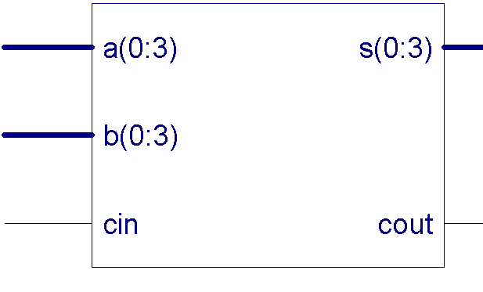

PROGRAME SOURCE CODE:
module csa_3(y,a,b,c);
output [4:0]y; input [3:0]a,b,c;
wire [3:0]s,ca; wire w1,w2,w3;
full_adder k1 (s[0],ca[0],a[0],b[0],c[0]);
full_adder k2 (s[1],ca[1],a[1],b[1],c[1]);
full_adder k3 (s[2],ca[2],a[2],b[2],c[2]);
full_adder k4 (s[3],ca[3],a[3],b[3],c[3]);
half_adder k8 (y[0],w1,s[0],ca[0]);
full_adder k5 (y[1],w2,s[1],ca[1],w1);
full_adder k6 (y[2],w3,s[2],ca[2],w2);
full_adder k7 (y[3],y[4],s[3],ca[3],w2);
endmodule
module full_adder(s,co,a,b,ci);
input a,b,ci; output s,co;
wire c1,c2,s1; half_adder x1(s1,c1,a,b);
half_adder x2(s,c2,s1,ci);
or(co,c1,c2); endmodule
module half_adder(s,c,a,b);
output s,c; input a,b;
xor(s,a,b); and(c,a,b);
endmodule
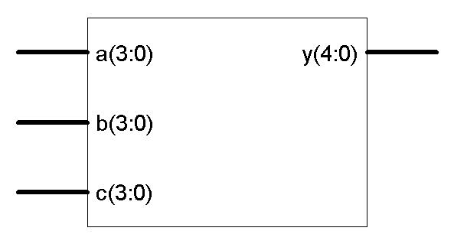

PROGRAME SOURCE CODE:
library ieee;
use ieee.std_logic_1164.all;
entity dec is
port(s: in std_logic_vector(2 downto 0);
g1,g2,g3: in std_logic;
y:out std_logic_vector(7 downto 0));
end entity; architecture dec3to8 of dec is
signal en: std_logic;
begin en<=g2 or g3;
process(g1,g2,s)
begin
if(g1='1' and en='0')then
case s is
when"000"=>y<="11111110";
when"001"=>y<="11111101";
when"010"=>y<="11111011";
when"011"=>y<="11110111";
when"100"=>y<="11101111";
when"101"=>y<="11011111";
when"110"=>y<="10111111";
when"111"=>y<="01111111";
when others=>null;
end case;
else
y<="11111111";
end if;
end process;
end architecture;
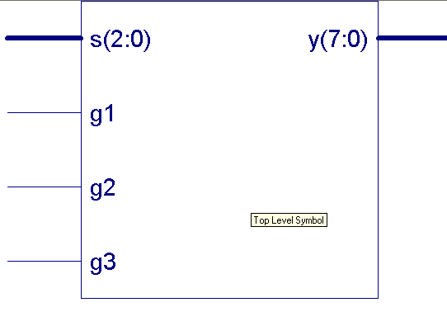

PROGRAM SOURCE CODE:
library ieee;
use ieee.std_logic_1164.all;
entity mux2 is
port(a,b,s:in bit;
y:out bit);
end mux2;
architecture dataflow of mux2 is
begin
y<=b when s='1' else a;
end dataflow;
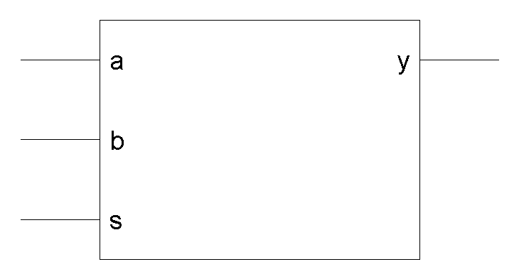

PROGRAM SOURCE CODE
library IEEE;
use IEEE.STD_LOGIC_1164.ALL;
use IEEE.STD_LOGIC_ARITH.ALL;
use IEEE.STD_LOGIC_UNSIGNED.ALL;
---- Uncomment the following library declaration if instantiating
---- any Xilinx primitives in this code.
--library UNISIM;
--use UNISIM.VComponents.all;
entity barrelshifter is
port(d :in std_logic_vector (7 downto 0);
c :in std_logic;
l :in std_logic;
r :in std_logic;
do:out std_logic_vector (7 downto 0));
end barrelshifter;
architecture Behavioral of barrelshifter is
signal iq:std_logic_vector(7 downto 0);
begin
process(d,c,l,r)
begin
if(r='1') then ---iq<=(others=>'0');
do<="00000000";
elsif(l='1') then
do<=d;
else
do<=d(6 downto 0)& d(7);
end if;
end process;
end Behavioral

TEST BENCH:
module tb_universal_shift();
reg s0,s1,left,rite,clk,clr;
reg [3:0]pin; wire [3:0]a;
universal_shift h2 (s0,s1,pin,left,rite,a,clk,clr);
initial begin
clk=1'b1; clr=1'b0; s0=1'b1; s1=1'b1;
#2 pin=4'b0001; #2 left=1'b1; rite=1'b1;
#100 s0=1'b0; s1=1'b1; #100 s0=1'b1; s1=1'b0;
#100 s0=1'b0; s1=1'b0;
end
always #5 clk=~clk; always #50 clr=~clr;
initial #150 $stop;
initial
$monitor($time,"s0=%b,s1=%b,pin=%b,left=%b,rite=%b,a=%b,clk=%b,clr=%b",s0,s1,pin,left,rite,a,clk,clr);
endmodule

TEST BENCH:
module tb_pipeline_adder();
wire [1:0]rega,regb,regc;
reg [1:0]d;
reg clk,reset;
pipeline_adder t6 (rega,regb,regc,d,clk,reset);
initial begin
d=2'b00; reset=1'b0; clk=1'b0;
end always #20 d=d+1'b1; always #2 clk=~clk;
always #200 reset=~reset;
initial #200 $stop;
initial $monitor($time,"rega=%b,regb=%b,regc=%b,d=%b,clk=%b,reset=%b",rega,regb,regc,d,clk,reset);
endmodule

TEST BENCH:
module tb_ring_counter();
reg en,reset,clk;
wire [3:0]count;
ring_counter h4 (en,reset,clk,count);
initial begin
reset=1'b1; clk=1'b0; en=1'b0;
#3 reset=1'b0; #50 reset=1'b0;
End always #5 clk=~clk;
always #5 en=~en;
initial #200 $stop;
initial $monitor($time,"en=%b,reset=%b,clk=%b,count=%b",en,reset,clk,count);
endmodule

TEST BENCH:
module tb_mull_4bit();
reg [3:0] a,b; wire [7:0] s;
initial
begin
a=4'b0010;
b=4'b0001;
end
mull_4bit DUT (s,a,b);
initial #100 $stop;
initial $monitor($time,"s=%b,a=%b,b=%b,",s,a,b);
endmodule

TEST BENCH:
module tb_csa_3();
wire [4:0]y;
reg [3:0]a,b,c;
csa_3 t5 (y,a,b,c);
initial
begin
a=4'b0010;
b=4'b1010;
c=4'b0110;
end
initial #100 $stop;
initial $monitor($time,"a=%b,b=%b,c=%b,y=%b",a,b,c,y);
endmodule

TEST BENCH:
module tb_lfsr();
parameter l=8; parameter is=8'b10010001;
parameter [1:l]tc=8'b1111_0011;
wire [1:l]y; reg clk,reset;
lfsr m4 (y,clk,reset);
initial
begin reset=1'b0;
clk=1'b0; end
always #2 clk=~clk;
always #5 reset=~reset;
initial #200 $stop;
initial $monitor($time,"y=%b,clk=%b,reset=%b",y,clk,reset);
endmodule

TEST BENCH:
module tb_rca_4bit();
reg cin;
reg a0,a1,a2,a3;
reg b0,b1,b2,b3;
wire s0,s1,s2,s3;
wire cout;
initial
begin
cin=1'b0;
a0=1'b0; a1=1'b0; a2=1'b0; a3=1'b0;
b0=1'b0; b1=1'b0; b2=1'b0; b3=1'b0;
end
rca_4bit x1(s0,s1,s2,s3,cout,cin,a0,a1,a2,a3,b0,b1,b2,b3);
always
begin
#2 a0=1'b1; a1=1'b0; a2=1'b1; a3=1'b0;
#2 b0=1'b1; b1=1'b1; b2=1'b0; b3=1'b0;
#2 cin=1'b1;
#2 a0=1'b1; a1=1'b0; a2=1'b1; a3=1'b0;
#2 b0=1'b1; b1=1'b1; b2=1'b0; b3=1'b0;
end
initial #100 $stop;
initial $monitor($time,"a0=%b,a1=%b,a2=%b,a3=%b,b0=%b,b1=%b,b2=%b,b3=%b,s0=%b,s1=%b,s2=%b,s3=%b,cin=%b,cout=%b",a0,a1,a2,a3,b0,b1,b2,b3,s0,s1,s2,s3,cin,cout);
endmodule

st1: begin z=(a)?1:0; n_state=(a)?st0:st1; end
st2: begin z=0; n_state=(a)?st1:st2; end
default: begin z=0; n_state=st0;
end endcase endmodule
TEST BENCH:
module tb_mealy_st0();
reg a,clk,reset;
wire z; mealy_st0 f4 (a,clk,reset,z);
initial begin a=1'b0; clk=1'b0;
reset=1'b0; #5 a=1'b1;
#6 a=1'b0; #5 a=1'b1;
#45 a=1'b0; end
initial forever #3 clk=~clk;
initial #100 $stop;
initial $monitor($time,"a=%b,clk=%b,reset=%b,z=%b",a,clk,reset,z);
endmodule

